ANNEX D - SPECIMEN PACKAGING, MARKING & LABELLING AND DOCUMENTATION INSTRUCTIONS

- CLASSIFICATION OF INFECTIOUS SUBSTANCES FOR SHIPMENT

Under the current United Nations Regulations (2003), infectious substances are classified according to two transportation categories based on a detailed, case-by-case, risk assessment of microorganisms known to be pathogens. The new transport categories are:

Category A:

An infectious substance which is transported in a form that, when exposure to it occurs, is capable of causing permanent disability, life-threatening or fatal disease to humans. These substances are given the shipping name of “Infectious substances affecting humans” and the UN Shipping Number: UN 2814. Category A substances are to be packed in accordance with International Air Transport Association (IATA) Dangerous Goods Packaging Instructions PI 602.

Category B:

Any infectious substance, which does not meet the criteria for inclusion in category A. Clinical/diagnostic specimens from patients when testing for polio, measles and rubella are classified as Category B under the UN Model Regulations. Category B substances are to be packed in accordance with IATA Dangerous Goods Packaging Instructions PI 650

Category B substances are given the shipping name of “Diagnostic Specimens”, “Clinical Specimens”, or “Biological substance, category B” and the UN Shipping Number: UN 3373. [Note on 1 January 2007, it is anticipated that the use of the shipping names “diagnostic specimens” and “clinical specimens” will no longer be permitted]

Note that for the US Associated Territories, more stringent packaging instructions maybe be followed and these countries should be guided by recommendations from their Regional Laboratory Coordinator.

- REDUCING RISK – APPROPRIATE PACKAGING

Appropriate packaging can reduce the risks to those engaged in the transport of infectious substances, as it provides the necessary and sufficient barriers to prevent leakage of the material to the outside. For the packing of both Category A and B substances, a 3-part (or triple) system of packaging is used, that comprises a primary receptacle, secondary packaging and rigid outer packaging. The use of triple packaging has over the years provided effective containment of infectious substances.

WHO has supplied shipping containers for all Hospital Based Reporting Sites in the Pacific. The smaller containers (HazPak) comply with IATA PI 650 and can only be used to transport Category B substances. The larger containers (Bio-Bottle) comply with IATA PI 602 and can be used to transport both Category A and B substances. WHO recommends that these containers be used for all shipments to laboratories when countries need to test both stool and blood samples for polio, measles or rubella.

- PACKING INSTRUCTION

PI 650 – Category B Substances

When shipping Category B substances [except where local airlines require all specimens to be sent as PI 602], please use the HazPak (or similar) shipping containers supplied by WHO. Shippers of Category B substances must comply with the requirements below and ensure that shipments are prepared in such a manner that they arrive at their destination in good condition and that they present no hazard to persons during shipment. The packing conditions are:

- For liquid substances (e.g. blood or serum specimens for measles/rubella testing)

The primary receptacle(s) must be leak-proof and must not contain more than 1 L; The secondary packaging must be leak-proof;

If multiple primary receptacles are placed in a single secondary packaging, they must be either individually wrapped or separated to prevent contact between them;

Absorbent material must be placed between the primary receptacle and the secondary packaging. The absorbent material, such as cotton wool, must be in sufficient quantity to absorb the entire contents of the primary receptacle(s);

- For solid substances (e.g. Stool samples for AFP testing)

The primary receptacle(s) must be sift-proof, to retain the specimen at all times; The secondary packaging must be sift-proof to retain the specimen at all times;

If multiple primary receptacles are placed in a single secondary packaging, they must be either individually wrapped or separated to prevent contact between them;

If there is any doubt as to whether or not residual liquid may be present in the primary receptacle during transport then a packaging suitable for liquids, including absorbent materials, must be used.

An itemized list of contents must be enclosed between the secondary packaging and the outer packaging for all PI 650 shipments. Seal the list in a plastic bag to avoid the paper becoming wet from condensation.

Wet ice or prefrozen packs when used in a shipment must be placed outside the secondary container packaging(s) or alternatively in an overpack with one or more complete packages

marked in accordance for that type of shipment. If wet ice is used it should be in a leak-proof container and the outer packaging must also be leak-proof.

- MARKING AND LABELING

Labels and marking on the packaging are an essential source of information to communicate to everyone involved in the transportation process the contents of the package, the nature of the hazard and the applied packaging standards. Most “certified” shipping containers (e.g. Bio-Bottle) already include the appropriate labels and markings as part of the package.

All markings must be placed on the packaging so that they are not covered or obscured by any part of, or attachment to the packaging, or any other labels or markings. All markings must be:

- durable and printed or otherwise marked on, or affixed to, the external surface of the packaging or overpack

- readily visible and legible

- able to withstand open weather exposure without substantial reduction in effectiveness;

- displayed on a background of contrasting colors

4.1 Category B – PI 650

Each package containing diagnostic (or clinical) specimens must be marked, durably and legibly on the outside of the package with each of the following:

- The UN 3373 label must be displayed on the external surface of the outer packaging. The label must be in the form of a square set an angle of 45° (diamond-shaped) with each side having a length of at least 50 mm, the width of the line must be at least 2 mm, and the letters and numbers must be at least 6 mm high.

- The proper shipping name “Diagnostic specimen” or “Clinical specimen” in letters at least 6mm high must be marked on the outer package adjacent to the diamond-shaped mark.
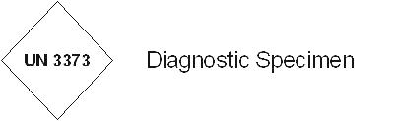

Example of the UN marking:
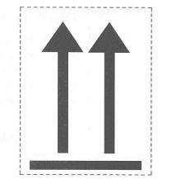

- Orientation labels are not required for shipments of diagnostic/clinical specimens but their use is recommended

- The full NAME AND ADDRESS of the shipper and the consignee

- Additionally, shipment containers should be marked with “Store at 4ºC whenever possible” or similar to identify that the shipping container must be kept cool at all times

- DOCUMENTATION

A Shipper's Declaration for Dangerous Goods is NOT required when shipping Category B substances that have been packaged according to PI 650.

Other documents that are required for specimen shipment, especially when sending to

VIDRL in Melbourne, Australia are:

- Customs Declaration (if required) [See Annex E1 & E2 for examples of customs declarations for AFP/AFR samples sent to VIDRL Australia. Please ensure that you are using a valid import permit and samples are addressed to the correct laboratory]

- Import permit (if applicable) [See Annex E3 for a sample import permit]

- EXAMPLES OF PACKAGING AND LABELLING

PI 650 Category B
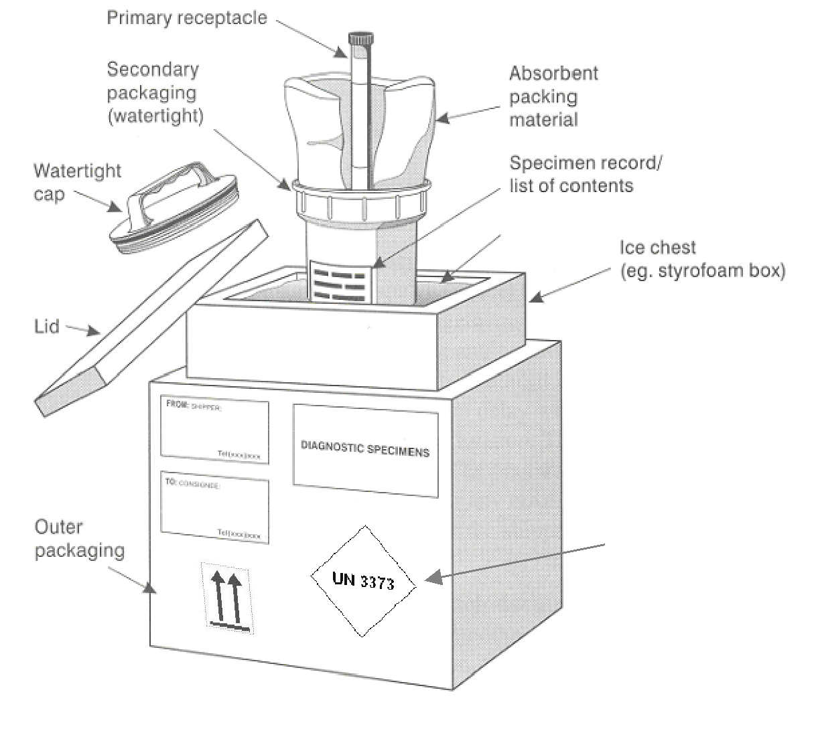

Ice Packs

Ice Packs

UN Marking

